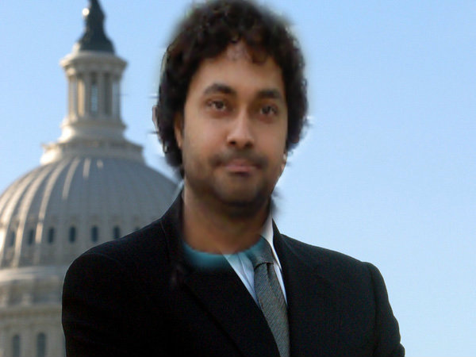

**2012**

**RESUME**

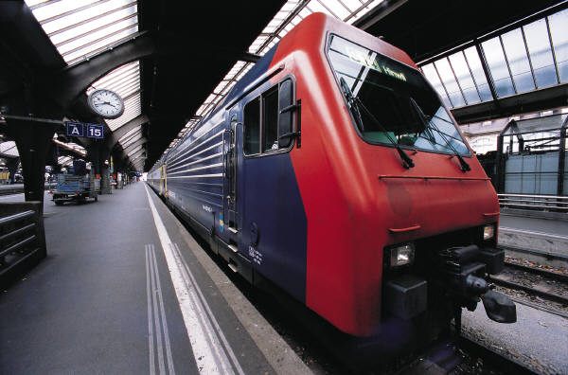Name- Amit tiwari

**[C.V.]**

Edcation-B.tech(Ece)

Age-7/1/1988

Gender-Male



Objectives-

* As I am a quick learner , and want to learn the latest technology avail so I can implement that in the practical manner.
* My strong point lies within my weak ones ,as I am a lazy starter but ones a started I can finish that work within the avail time and can use that space in some other work.

Strong points-

* I am a good motivator and having leading capability and can inspire others through my dedicated work.
* Having good communication skills and willing to learn the latest technology and implementation

# motion.jpg AMIT TIWARI

[AMIT TIWARI]

# 2012BNBBBB

response

[Type the company name]

1/1/2012

Shri. Rishi kant tiwari, near-anand talkies.lmp(u.p.)-262701-near-lucknow

Contact - Mobile No: 91 9315514140

# Education

|  |  |  |  |  |
| --- | --- | --- | --- | --- |
| **Course** | **Specialization** | **Institute** | **Year of Passing** | **%/Grade** |
| 10th | Science | G.i.c |  |  |
| 12th | math | G.i.c |  |  |
| B.tech | Electronics and communications | M.d.u | 2012 | 75% |
| Gate | Ece | Comption | 2012 | 1. persentile |

**Skills … …………… …………………**

* Diodes and transistors
* Semiconductor materials
* Telicommunications and Networks
* Radar and satellites
* C language
* Good communication skills and self belive and die heart attitude
* Can motivate others and leading skills

**Academic Projects ……………… …………**

* Cell phone operated robotic car-united project(lucknow)
* i.r. remote control on-off—(IEEE)
* tcp and udp-(Thinl Labs-IIT BOMBAY )
* At the school level project in nanotech or information based in IIT-KANPUR
* Project on bio-infromatics at the school level

# Achievments

* Gate score of 96 persentile in electronics and communications
* Got 75% in b.tech
* Participate in IEEE project lab(information based)
* Secured 2nd rank in school in 10th and got medal by an i.p.s
* 7.6 in IELTS
* Win cairum competition at the distric level

.

**Extra Curricular Activities…**

**…………… …………**

* Played C.K.NAYADU cricket tournament at the state level at green park Kanpur
* Participate in iit –kanpur at the project of nanotechnology at the school visit
* Litracy and blood donation

**Interests & Hobbies ……………… …………**

* Cricket,songs and music
* Likes to motivate others
* Want to learn latest technology so I can help the welfare of the society
* Likes to do inspiring work
* Want to create the example for others through my work
* Motivate others and give to them best knowledge to avail at my side

# Obiective

* Willing to learn the latest technology avail and very keen to implement that in practical manner.
* And want to distribute my knowledge so the peoples can benified.

**PERSANAL DETAILS -**

**Email-** [**address-tiwariamitrishi88@gmail.com**](mailto:address-tiwariamitrishi88@gmail.com)

**Gender-male**

**D.O.B-7/1/1988**

**Mobile no.- 09315514140**

# 